Implement Azure Container Apps (ACA)

Lab Objective
In this lab, you will:
- Create an Azure Container App
- Use a managed container environment
- Deploy a Hello World container
- Access the application using a public URL
- Understand how Azure Container Apps simplifies Kubernetes

Business Scenario (Why This Lab Exists)
Your organization:
- Runs applications on on-premises virtual machines
- Wants to move to the cloud
- Does not want to manage:
  - Servers
  - Kubernetes clusters
  - Scaling logic
➡ Azure Container Apps (ACA) provides a serverless container platform built on Kubernetes without the operational complexity.

Architecture diagram
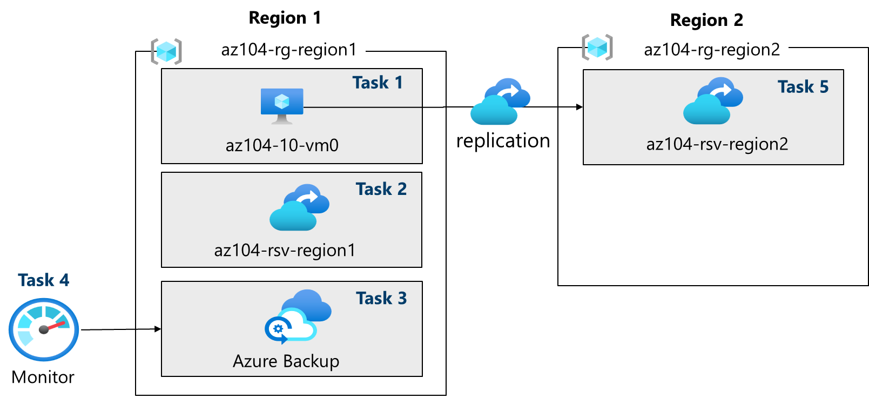
Core Concepts (Understand First)

What is Azure Container Apps?
Azure Container Apps (ACA) is:
- A serverless container platform
- Built on managed Kubernetes
- Fully managed by Azure
You do not manage:
- Nodes
- Kubernetes control plane
- Scaling infrastructure
You only manage:
- Container image
- Application configuration
- Scaling rules

Azure Container Apps vs AKS (High-Level)
Feature | Azure Container Apps | Azure Kubernetes Service
Kubernetes management | Fully managed | Customer managed
Cluster visibility | Hidden | Full control
Scaling | Automatic | Manual + autoscale
Complexity | Low | High
Best for | Web apps, APIs | Complex microservices

What is a Container Apps Environment?
A Container Apps Environment:
- Is a logical boundary for container apps
- Hosts:
  - Networking
  - Logging
  - Scaling infrastructure
- Can contain multiple container apps
Think of it as:
A managed Kubernetes environment created automatically for you.

What is a Quickstart Image?
A Quickstart image:
- Is a prebuilt container image
- Used for learning and testing
- Requires no custom code
In this lab:
- A simple Hello World container is used

Task 1: Create and Configure an Azure Container App

What You Did
- Created a container app
- Created a new container apps environment
- Deployed a sample web application

Key Configuration Definitions

Container App Name
Logical name for the containerized application.

Container Apps Environment
- Created automatically
- Used by the container app for:
  - Networking
  - Scaling
  - Logging
Multiple apps can share one environment.

Region
- Location where the container app runs
- Example: East US

Quickstart Image – Simple Hello World
- Lightweight container
- Listens on port 80
- Displays a success message

Task 2: Test and Verify Deployment

What You Verified
- Container app deployment succeeded
- Azure generated a public DNS URL
- Application is accessible via browser

Application URL
Azure Container Apps automatically provides:
- HTTPS endpoint
- Load-balanced access
- Public DNS name
No additional networking configuration required.

What Happens Internally?
Azure:
- Creates a managed Kubernetes environment
- Deploys the container
- Configures ingress
- Handles scaling automatically
All without exposing Kubernetes complexity.

